ENGLISH PLACEMENT TEST PRESENT

Solve this test in in a piece of paper

Choose the correct form of the verb “be”

- Julio ________ my sister’s boyfriend
- Is
- Are
- Am
- Aren´t

- Joe __________ at home now.
- Am
- Aren’t
- Isn´t
- Are

- ________you Mary’s brother?
- Is
- Isn´t
- Are
- Am

- That _________ my pen. It´s Ann´s.
- Are
- Is
- Isn´t
- Aren´t

- ________ she their mother?
- Am
- Aren´t
- Is
- Are

- My boss _______ Tom. He ______ in his office.
- Am – is
- Is – is
- Is – am
- Are – Am

- Sue and Bill ________ Greek. They _______ from Greece.
- Are - are
- Is – are
- Isn´t - are
- Are – is

- _______ you busy? Yes, I _________at work until 9:00 pm.
- Am – are
- Are– am
- Is – are
- Are – is

- Where _______ Hyundai from? It _________ from Korea.
- Are – am
- Is – am
- Is- is
- Is – are

- Ted´s mother ________ very young, she _________ 75 years old.
- Is – am
- Is - are
- Isn’t – is
- Are – is

Circle the correct order of the sentence. (From 11 to 13)

- my / pencil / isn’t / it
- Isn’t / my / it / pen
- It / isn’t / my/ pen.
- pen/ it/ my / isn’t.

- We / not / friends / are .
- We / are / not / friends.
- We / not / are /friends.
- We / friends / are / not.

- He / is / not / tall.
- He / not / is / tall.
- Is / he / not / tall.
- Not / he / is / tall.

Choose the correct article. (From 14 to 18)

- In the fridge there is ___ apple, _____ pear and ____watermelon.
- A – an - a
- An - an- a
- A – an – an
- An – a - a

- I have _______ excellent friend and he has _____ good job.
- An - a
- A – a
- An – an
- A – an

- In the garage there is ______ old car and ______ new one.
- A - a
- An – an
- A – an
- An - a

- He is eating _______ ice cream and drinking ______ glass of water.
- An - an
- An – a
- A – a
- A - an

- In the garden there is ______ ant, ______ worm and _____ spider.
- A – a – an
- A – a – a
- An – a – a
- An – a – an

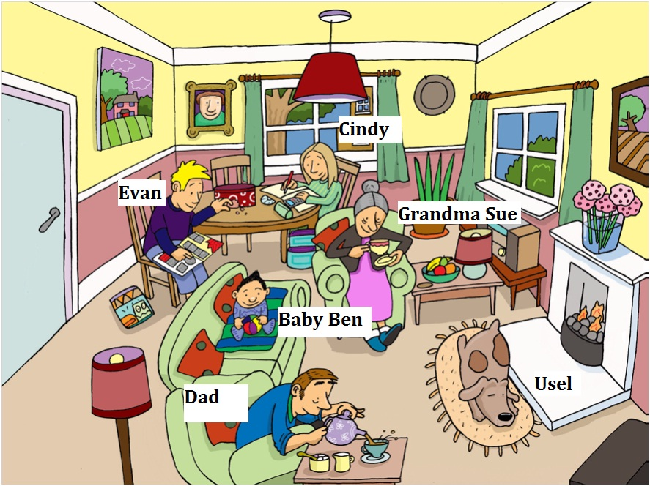
Circle the correct sentence according to the picture. (From 19 to 23)

- There is a picture behind the window
- There is a picture next to Usel.
- There is a picture on the night table.
- There is a picture behind Evan.

- There are three lamps on the chimney
- There are three lamps next to grandma
- There are three lamps in the house
- There are three lamps on the floor

- There are five chairs in the house.
- There are five armchairs in the house
- There are two chairs in the house
d. There are three chairs in the house

- There is a dog on the rug next to the chimney
- There is a dog on the rug in front of the chimney
- There is a dog on the chimney next to the rug
- There is a dog under the chimney.

- .
- There is a radio between the windows.
- There is a radio in front of the window
- There is a radio on the floor behind the window.
- There is a radio behind the window.

Read the text and choose the correct answer from 24 to 30.
Jacquie’s day
Every day she gets up at seven o´clock. She has a shower then she gets dressed. She usually has a big breakfast: cereal, toast, fruit and coffee. She always stars work at nine o'clock. At quarter past one She usually has lunch with her colleagues in the cafeteria. She finishes work at six o'clock. She gets home at quarter to eight. She takes dinner at half past eight. Then she sometimes watches TV. She often goes to bed at half past eleven.

- She gets up at seven o’clock.
- She gets up early to go to work.
- She gets up after shower.
- She usually gets up early

- She never has a big breakfast.
- She has a big breakfast.
- She has breakfast before shower.
- She gets dressed after breakfast.

- She usually stars work at one o'clock.
- She sometime stars work at nine o'clock
- She always stars work at nine o'clock
- She often starts work at nine o’clock.

- She never has lunch with her colleagues in the cafeteria
- She doesn’t have lunch with her colleagues.
- She usually has lunch at one fifteen with her colleagues.
- She usually has lunch with her colleagues in the restaurant

- She doesn’t get home at quarter to eight
- She never gets home at quarter to eight
- She gets home at seven forty-five
- She sometimes gets home at quarter to eight
.

- She has dinner before she watches tv.
- She has dinner after she watches tv.
- She sometimes has dinner before she goes to bed.
- She never takes dinner before she watches tv.

- She often goes to bed at eleven thirty.
- She sometimes goes to bed at night.
- She usually goes to bed at eleven thirty.
- She never goes to bed at eleven thirty.

Choose the correct sentence. (From 31 to 41)

- She studying English and French.
- She’s studying English and French.
- She study English and French.
- She is studies English and French.

- I traveling to Chile.
- I travels to Chile
- I’m traveling to Chile .
- I’m travel to Chile

- I goes to bed at 11 pm.
- I going to bed at 11 pm
- I’m going to bed at 11pm.
- I’m go to bed at 11 pm

- I copies the information.
- I’m copy the information
- I’ coping the information.
- I’m copying the information

- I listens to the radio.
- I’m listening to the radio.
- I’m listen to the radio
- I listening to the radio.

- Yes, I am.
- Yes, I am not
- No, I do.
- No, I am.

- Is there a milk?
- Are there a milk?
- Are there many milk?
- Is there any milk?

- How many water are there?
- How many water is there?
- How much water is there?
- How much water are there?

- There aren’t any apples.
- There isn’t any apples.
- There is many apples.
- There are a banana.

- Is there a bananas?.
- Is there any banana ?
- There is some bananas
- There is any banana

- Are there some apples?
- There isn’t any apples.
- There are any apples.
- Is there any apple?

Circle the correct verb. (From 42 to 50)

- Hi Meg! What are you ______________?
- Do.
- Don’t
- Did.
- Doing.

- I’m __________________ with my sister.
- chat
- chatting
- chats.
- chatted.

- Where does he usually __________on saturdays?
- Go
- Going.
- Goes.
- Went.

- She’s _______ lasagna with her mom.
- cooks
- cook.
- cooked
- cooking

- She never ________ to work.
- walked.
- walking.
- walks.
- walk.

- He’s a chef. He _________ in Ilforno.
- Work.
- Working.
- Worked.
- Works.

- Do you __________ a new laptop?
- get.
- gets.
- got .
- getting.

- She says she´s________ a show.
- perform
- Doesn’t perform.
- performed
- performing

- He is ________ his bed now.
- makes.
- making.
- made.
- make.

According to the pictures choose the correct action. (From 51 to 55)

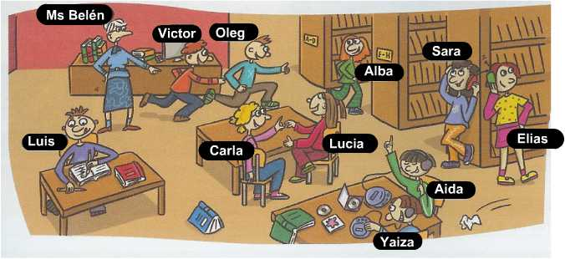

51.
- Luis is eating a cake.
- Luis singing now.
- Luis is reading a magazine.
- Luis is writing on the notebook.

- Ms Belen is pointing victor.
- Ms Belen is talking to victor.
- Ms Belen is chatting with victor.
- Ms Belen is running behind victor.

- Aida and Yaiza are listening to the teacher
- Aida and Yaiza are talking together.
- Aida and Yaiza are listening to the cd..
- Aida and Yaiza are listening to each other

- Victor is chasing to Oleg.
- Victor is jumping with Oleg.
- Victor is playing with Oleg.
- Victor is talking to Oleg.

- Sara is standing next to Elias.
- Sara is talking to Elias.
- Sara is eating with Elias.
- Sara is drinking with Elias.

Circle the correct sentence (from 56 to 70)

- They can playing the piano and speak English.
- They can plays the piano and speaks English
- They can play the piano and speak English.
- They can’t playing the piano and speakng English

- A turtle can run fast.
- A turtle can’t run fast.
- A turtle can running fast.
- A turtle can’t running fast.

- Tim can speak two languages English and French.
- Tim can’t speaks two languages.
- Tim can speaks two languages English and French.
- Tim can’t speaking three languages.

- Can Maria curl her tongue?.
- Can Maria curls her tongue?.
- Can’t Maria curls her tongue?.
- Can Maria curling her tongues?.

- type / really / can / well / I /.
- can / well / type / really / I/
- can / type/ well/ I / really /.
- I / can / type / really / well /.

- we / can / not / make / handcrafts .
- we / not / handcrafts / can / make .
- we / make / not / can / handcrafts .
- we /can / make / handcrafts / not.

- they / can/ writes / English / but /they/ can / speak /.
- English / speak / but / they/ write / can’t /can/they/
- they / can’t / write / but / they / can / English / speak /.
- they / can / write / English / but / they / can’t / speak /.
- they / can / write / English / but / they / can / speaks /.

- Joel can cross his eyes.
- Joel can cross her eyes.
- He can crossing his yes.
- He can’t crossing his eyes.

- Andrew likes to dance and singing.
- Andrew like to dance and to sing.
- Andrew likes dancing and sing.
- Andrew likes dances and singing.

- What is she reading?
- What does she read?
- What is she read?
- What is she reads?

- Where’s she goes?
- Where’re she going?
- Where is she going?
- Where are she going?

- Where traveling are you on vacation?
- Where are you traveling on vacation?
- Are where traveling you on vacation?
- Where traveling you are on vacation?

- Meg’s graduate this year.
- Meg’s graduating this year
- Meg’s graduated this year.
- Meg’s graduates this year.

- What instruments can Jeff play?
- How many people is there in his band?
- What instruments does they play?
- Is they good at playing the guitar?

- I’m write a letter to el Colombiano.
- I’m writes a letter to el Colombiano.
- I’m writing a letter to el Colombiano.
- I’m wrote a letter to el Colombiano.

Circle the correct word or group of words. (From 71 to 78)

- He wears _______ red t- shirt with ________pants.
- Short – tall.
- medium –.large
- large– brown.
- Medium – tall.

- He wears gold ________.
- Glasses.
- Hair.
- Brown eyes.
- Big nose.

- The dog has ____________.
- A Long and short tail.
- An long and brown tail.
- An long tail.
- A long tail.

- Diamonds ________ cheap.
- Are
- Be
- Aren’t
- Is

- Linda _______ at home, she __________ in the park.
- Aren’t - are
- Are - are
- Is - isn’t
- isn’t - are

- Lorie _________ from Paris next week.
- returns
- return
- returned
- returning

- She is a _________.
- Architect.
- Actor.
- Uncle.
- teacher.

- There are___ cars in the parking lot but there aren’t _____ motorcycle.
- A - some
- Some - a.
- Many - any
- Any - many

Circle the correct sentence. (From 79 to 82)

- does she help the kids in the school?
- do she help the kids in the school?
- does she helps the kids in the school?
- Is she help the kids of the neighborhood?

- Do the boy talk to the teacher?
- does the man talk to his wife?
- does the baby sleeps in the bed?
- do the children plays the pizza?

- does / buying / car /a/ he / new /.
- He / friend / writes / a / letter / to / his / is .
- His / friend / writes / is /a / letter / to / he .
- He / is / writing / a / letter / to / his / friend /

- We don’t study on line.
- We studies on line
- We does study on line.
d. doesn’t We study on line

Choose the odd word. (83 a 85)

83.
- Grandmother.
- Father .
- Ugly.
- Cousins

84.
- pencil
- Student.
- notebook.
- banana

85
- jump
- eat
- run.
- Walk

86.
- Tall.
- Kitchen.
- Bedroom.
- living room.

87.
- math.
- spanish.
- Social science
- psychologist.

Choose the correct sentence (from 88 to 90)

88.
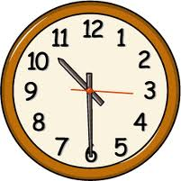
- It’s half past ten.
- It’s ten twenty.
- It’s six past ten.
- It’s ten past six.

89.

- It’s two thirty.
- It’s three past ten.
- It’s a quarter past two.
- It’s a quarter to three.

90.
- Martha and Kevin make the lunch at twelve o’clock.
- They makes the lunch at noon.
- Martha and Kevin cooks the lunch at noon .
- Martha and Kevin cooking the lunch at twelve o’clock

Choose the correct verb. (from 91 to 100)

91. He ________ a letter to his mother every month
- sending.
- sends.
- sents.
- sent.

92. Where do you ________ ?
- Lives.
- Live.
- Living.
- Life.

93.I always ________ to work at 6:00 a.m.
- go.
- Gone.
- Going.
- Goes.

94. My sister _____________ in English.
- Don’t speaks and writes
- No speak and no write
- Doesn’t speak and write
- Speaks and writes.

95. They __________ cars, they ___________ bikes
- Doesn’t sell – sells
- Don’t sell – sell
- Don’t sells– sell
- Don’t sell – sells
.

96. Rita_______ every day, she _________ on weekend .
- Don’t work - works.
- Doesn’t work - works
- Worked - work.
- Working – doesn’t work

97. Roger and Paul _______ vegetables and fruit
- Don’t ate.
- Doesn’t eat.
- Eat.
- Eats.

98. Are you British?
- Yes, I’m.
- No, I doesn’t.
- Yes, I does
- No, I don’t.

99. Does Sergio train every two days?
- No, he doesn’t.
- No, he don’t.
- Yes, he do.
- Yes, he is.

100. Do you eat junk food?
- No, I doesn’t.
- No, I don’t.
- Yes, I don’t.
- Yes, I am.

